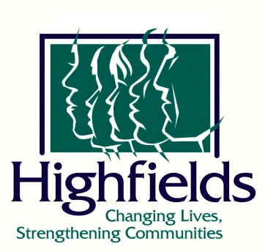
CONTACT: Emily Morgan FOR IMMEDIATE RELEASE
Communications and Marketing Specialist
emorgan@highfields.org

Dart Foundation awards $90,000 for Highfields’ 3 Year Matching Challenge

Onondaga, Michigan – February 12, 2021 – Highfields Inc., a multi-purpose human services organization for children and families, was awarded a conditional grant of $90,000 from the Dart Foundation for their 3 Year Matching Challenge Grant.

“Highfields is grateful to the Dart Foundation for their commitment to helping fulfill our mission of serving children and families throughout mid-Michigan,” said Brian Philson, Highfields’ President and CEO.

Payments of up to $30,000 will be awarded every year for the next three years as long as matching funds have been raised through Highfields’ annual fundraising events. Funds will help support children and families in Highfields’ programs.

The Dart Foundation is a private family foundation established by Dart Container Corporation founder William A. Dart and his wife Claire T. Dart. The Foundation supports projects that enhance education, especially in the areas of science, technology, engineering and math, and those that improve the quality of life in specific communities.

Highfields is a nonprofit human services organization which provides home-based counseling, residential care for young men ages 11-17, and experiential education and support programs for children, youth, and families in 13 mid-Michigan counties. For more information, please visit www.highfields.org.
###

